LMS PowerShell Script to Semi-automate the Process for Pulling RPE Scores

### Steps to run PS script

Step# 1: Copy runtime log by triple clicking. Open notepad++ , open new1.xml file located in the Input Files folder and paste the copied log.

Note: Usually the log that needs to be copied should have the status Complete and Failed. In case all the logs are incomplete or satisfaction status in unknown, copy all from the Runtime Log window and paste. Keep only the question-answers by removing every tag that don’t have an “index”.

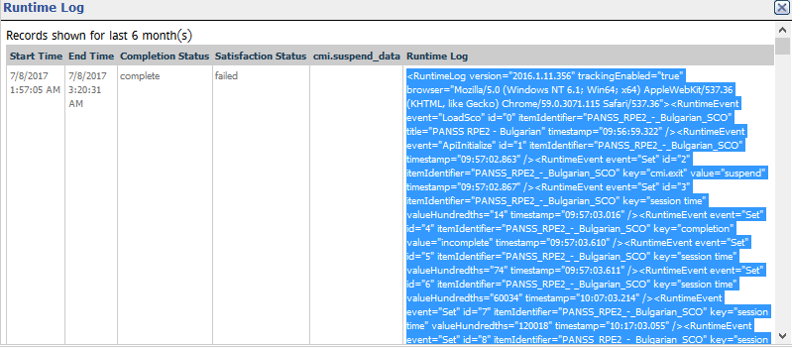

Step# 2: Select all by pressing Ctrl+A and then press Ctrl+Alt+Shift+B to indent in a clean XML format.

Note: XML Tools plugin should be installed in notepad++ in order for the latter shortcut to work.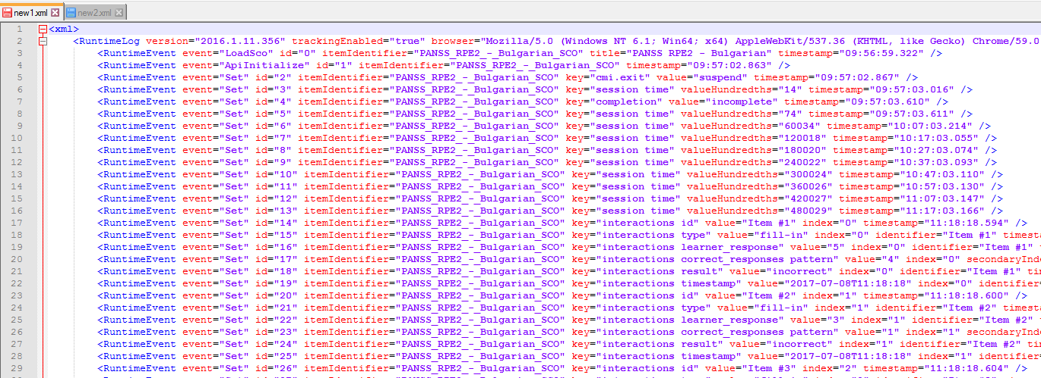

Step# 3: Remove any unnecessary indexes. For Tutorial/Post Tests, remove the indexes 20 and 21. Now divide the log into two files, new1.xml and new2.xml.

new1 will contain indexes from 0-9 and new2 will contain 10-19.

Step# 4: Save the file

Step# 5: Go to the LMSScript folder and run the file “RunMe.bat”

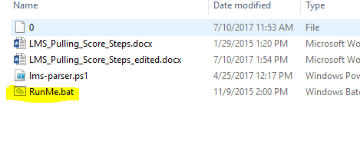

Step# 6: Follow the instructions given in the script.

It will first prompt for the sample excel file, select the desired sample file from the Input Files folder.

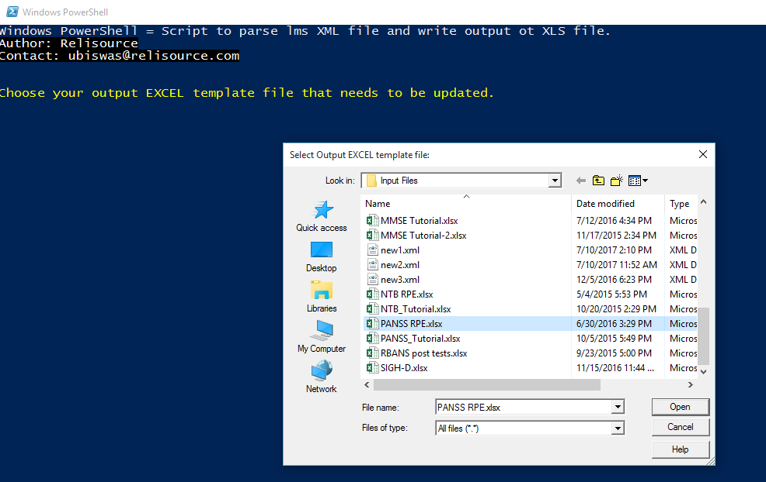

Step# 7: Next it will prompt for the xml file you just prepared. Select your prepared xml file. For Tutorial/Post tests, it will prompt for xml file twice.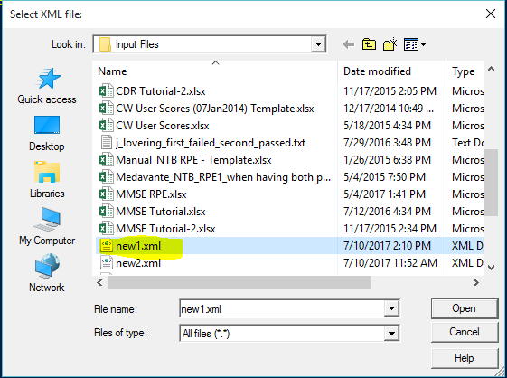

Step# 8: The script will automatically close after the output file is prepared. In case there exists another file with the same name, the script won’t close and prompt for an overwriting request, just click Yes.

Step# 9: Now open the newly generated file from the Output folder, the file will be named as “CW User Scores_Month Day.xlsx” where Month and Day is of the current date. Edit the username as the script does not put username in automatically. The course name might also need some modification.

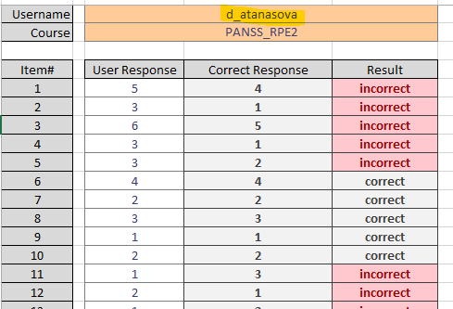

Step# 10: Attach the excel file and mail it to the recipient.

### Prerequisites:

1. OS: Windows 7, Power shell version greater than 2.0 or 2.0
2. XML files
3. Microsoft Excel 2007 or greater
4. Excel file templates